**Question 1: -** You work in a Sales company and you are given with two data files: ListOfOrders.csv and Order Breakdown.csv. Your manager needs two files:

**A:** In first file, Customer_RollNo.csv, there should be customer details who contribute to sales greater than $1000. [Create target file].

Step 1: - Login to Informatica Cloud and login with your registered email address, then click on Data Integration and open your created folder (SumitKumarLabh_11703319).

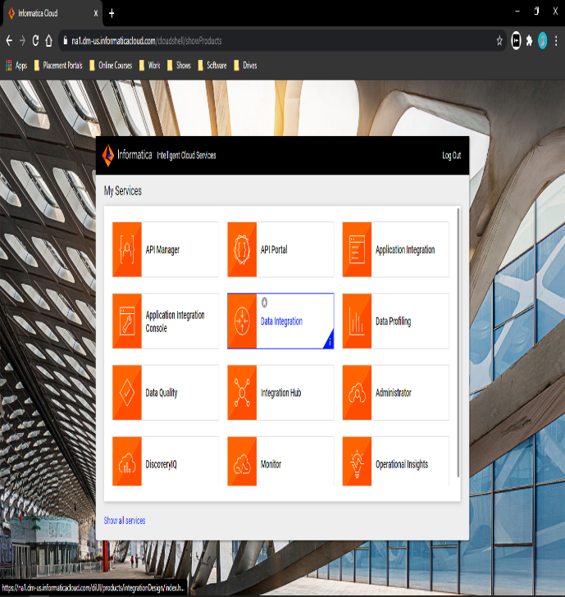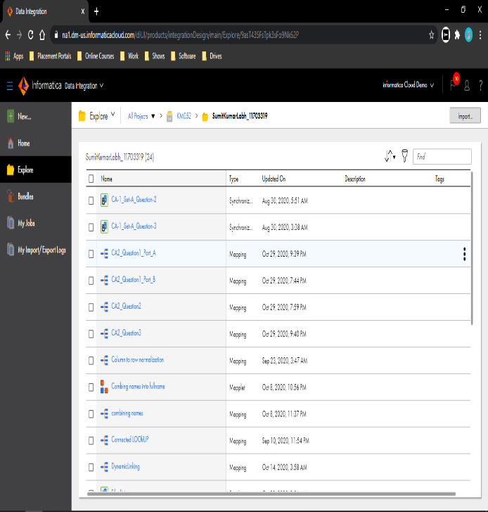

Step 2: - Select the new option from the upper left corner and go to task then select Mapping then click in create.

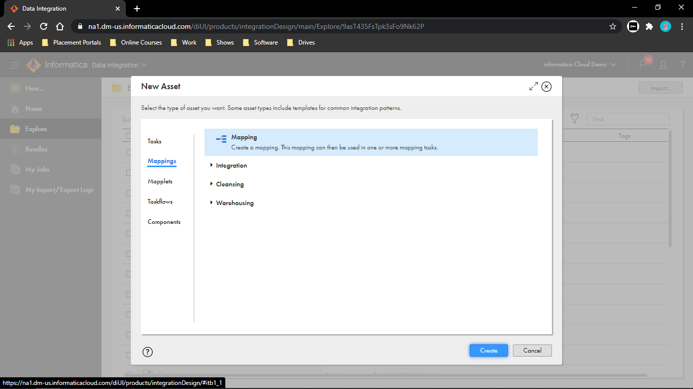

Step 3: - Select Source and give a name to it (OrderBreakdown). Go to source and establish a flat file connection then assign an object to it (OrdersBreakdown.csv).

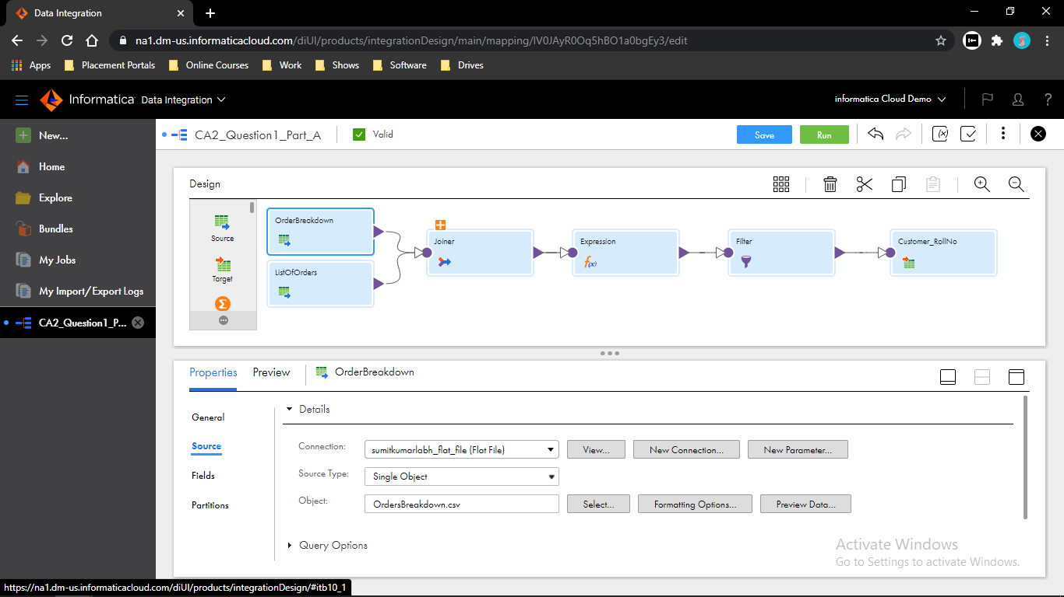

Step 4: - Insert a new source and give a name to it (ListOfOrders). Go to source and establish a flat file connection then assign an object to it (ListOfOrders.csv).

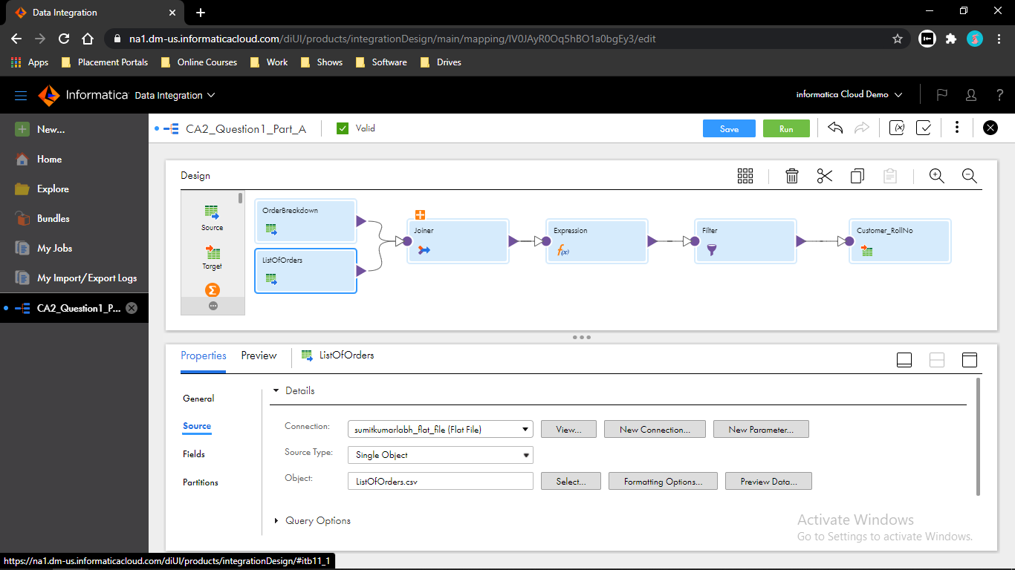

Step 5: - Insert a Joiner transformation and connect the two sources to it i.e. OrderBreakdown to Master and ListOfOrders to Details. Go to Join Condition then give a condition for joining Order_ID=Order_ID_.

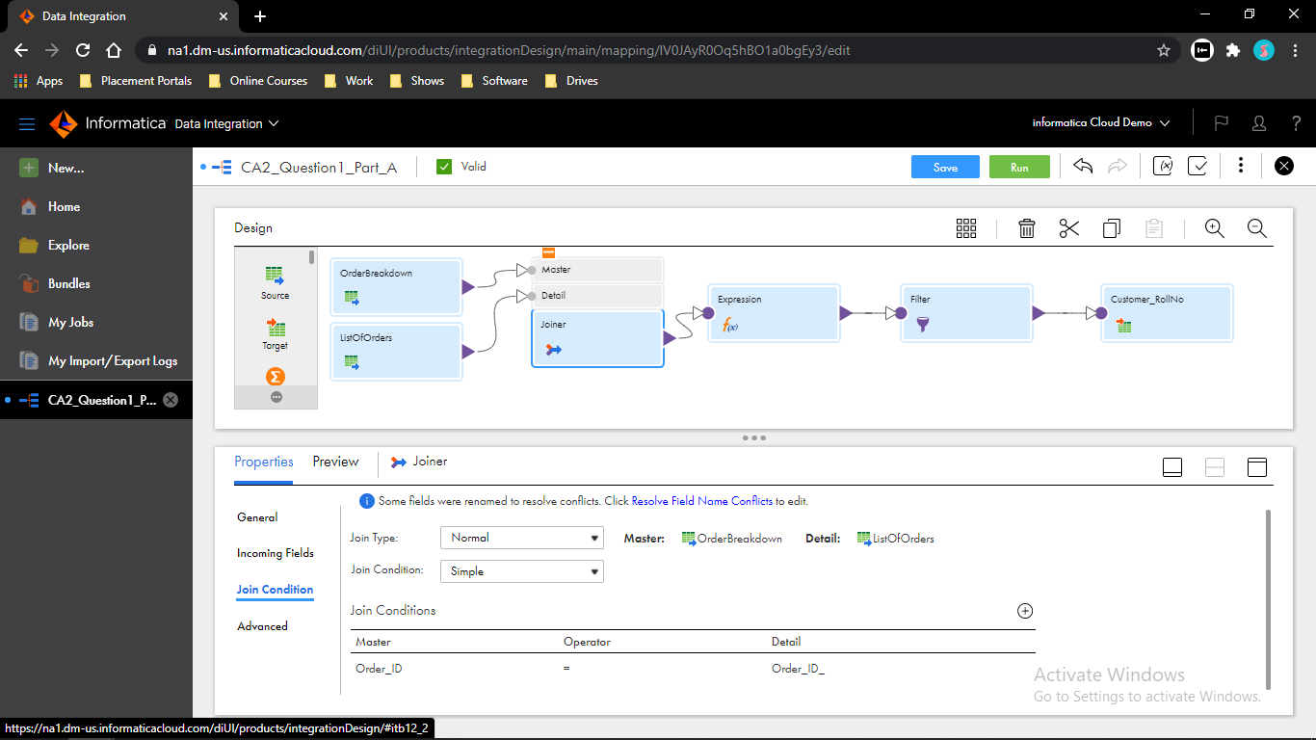

Step 6: - Insert an Expression transformation then go to expression option and create a new field Sales and configure it by clicking on configure. TO_INTEGER(Sale)

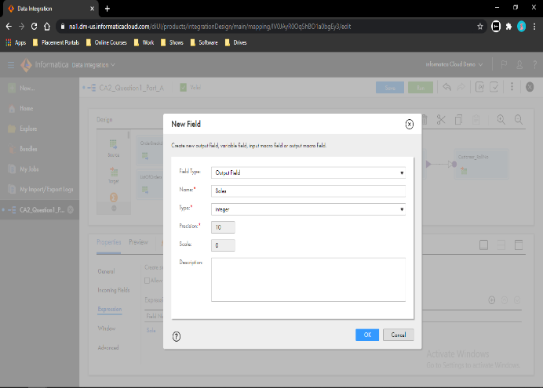 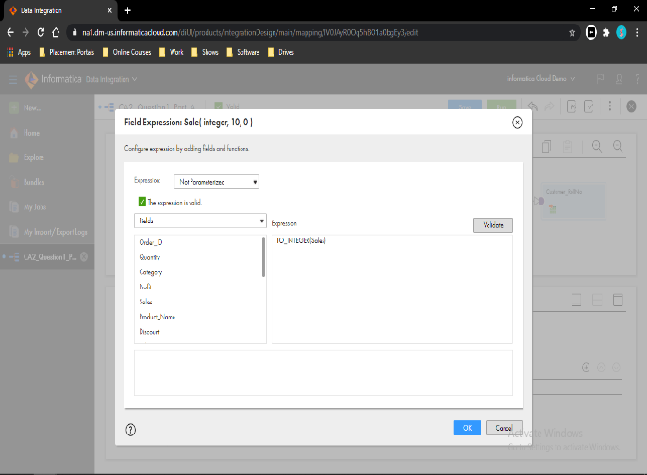

Step 7: - Insert a Filter transformation and go to filter option then give the filter condition. Sales > 1000

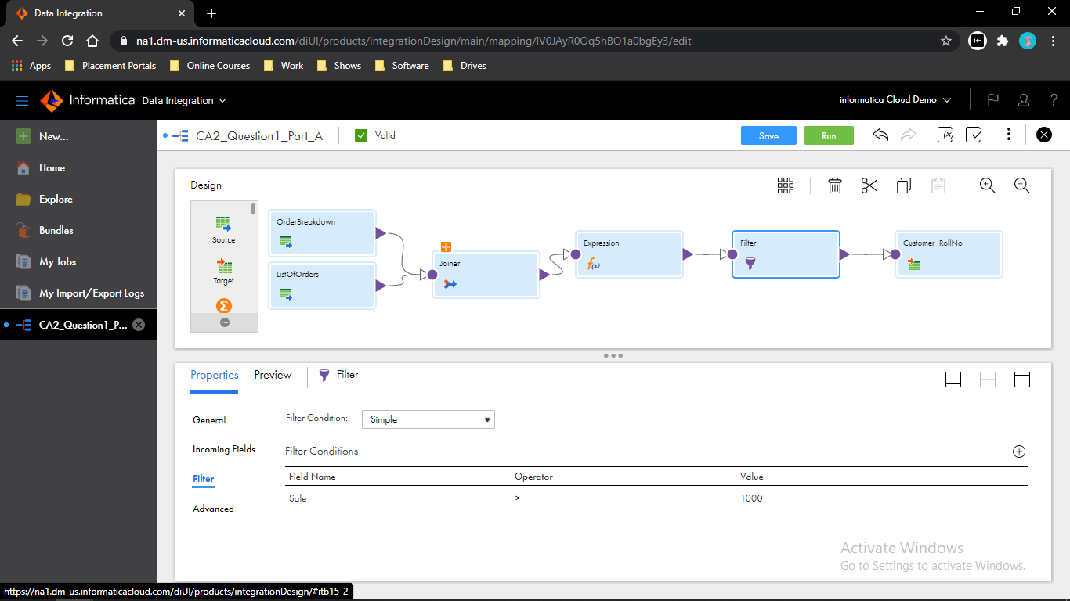

Step 8: - Go to Target and create a flat file connection and create a new object for it.

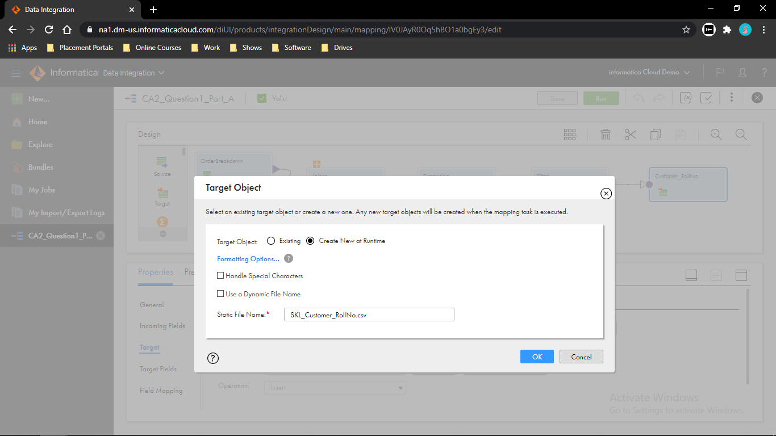 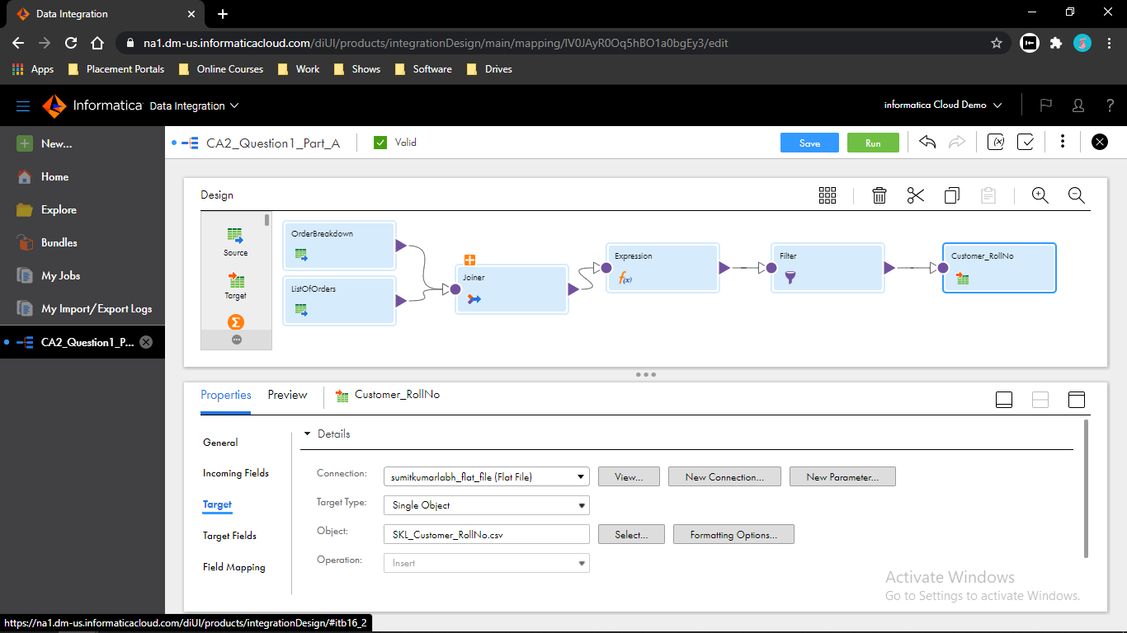

Step 9: - Save the mapping and run it then go to My Jobs to see the execution.

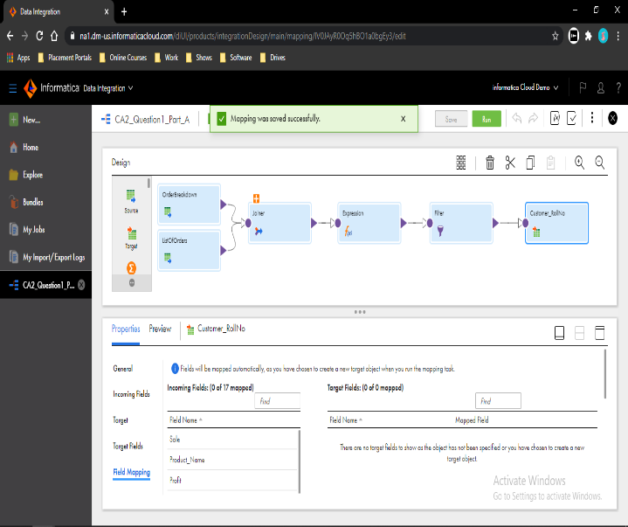 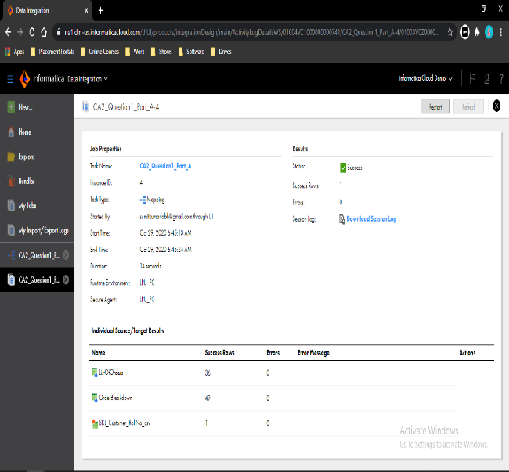

**B:** In second file emp_data.txt let’s suppose I am having a dataset “Employees” containing 5 columns (Eid,fullname, Salary,Department,JoiningDate). How we can extract only those records from the source to target file whose joining date is greater than 05/01/2008. [Create target file] Create a mapping in IICS to perform the above task. Use transformations as per requirement.

Step 1: - Select the new option from the upper left corner and go to task then select Mapping then click in create. Select Source and create a flat file connection and assign an object to it.(Employees.txt)

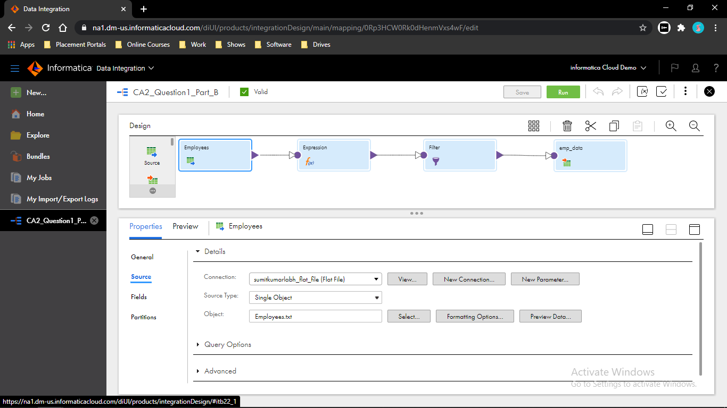

Step 2: - Insert an Expression transformation then go to expression option and create a new field JoinDate and configure it DATE_COMPARE(TO_DATE(Joining_Date,’DD/MM/YYYY’),TO_DATE(‘05/01/2008’,’DD/MM/YYYY’)).

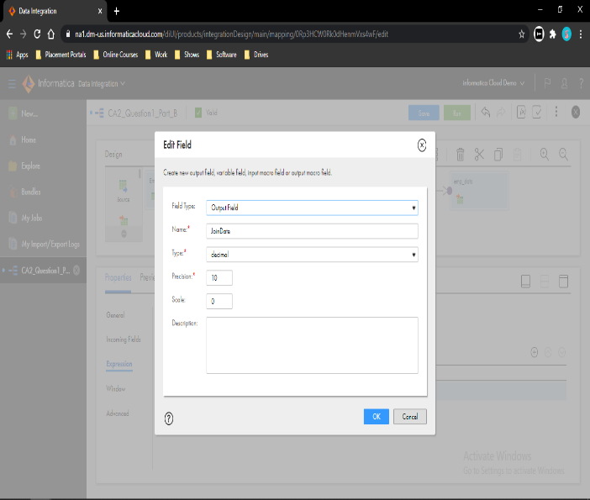 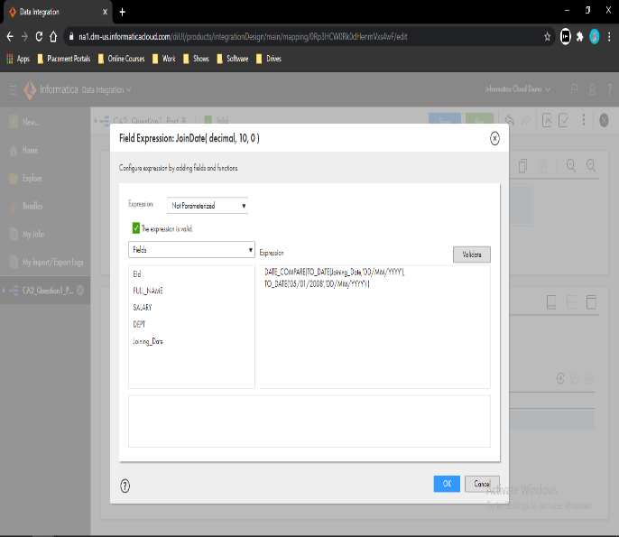

Step 3: - Insert a Filter transformation and go to filter option then give the filter condition to it.

JoinDate > 0

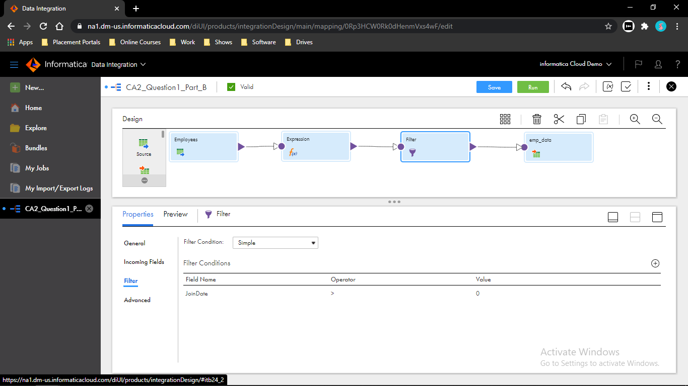

Step 4: - Go to Target and create a flat file connection and create a new object for it.

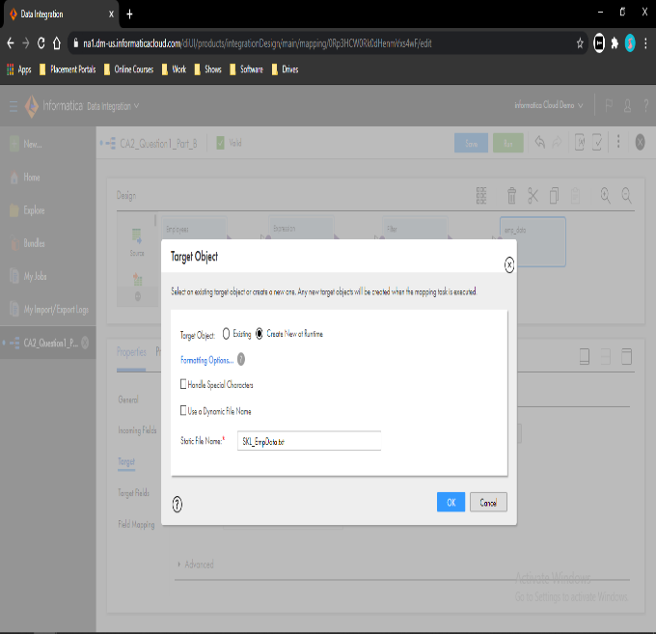 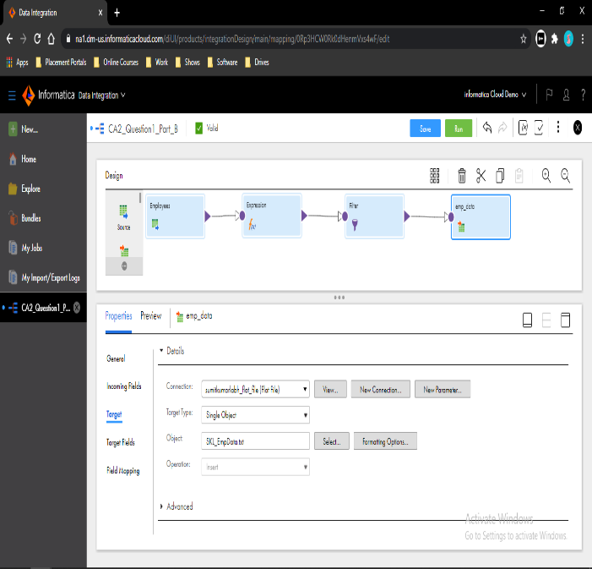

Step 5: - Save the mapping and run it then go to My Jobs to see the execution.

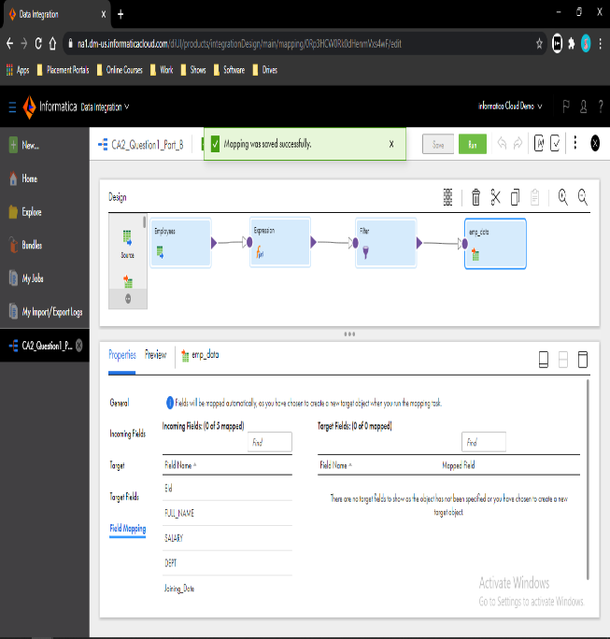 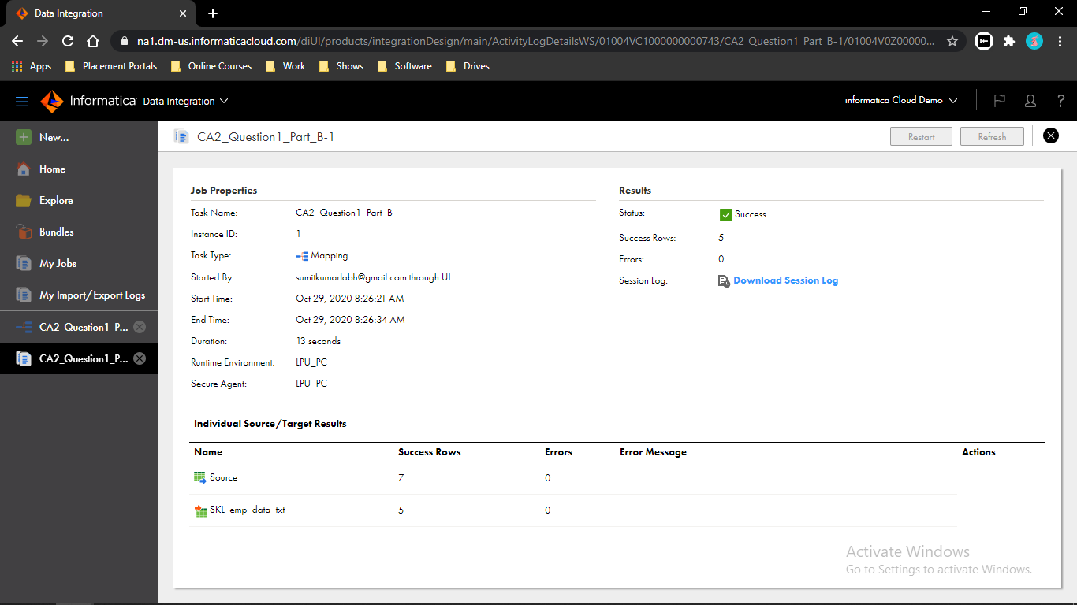

**Question 2:** - You are given with a file ListofFilms.csv. The aim of the exercise is to load a list of films into the FilmsTarget.csv table, setting the genre id for each film using GenreID.csv file. Create a Mapping using Lookup Transformation.

Step 1: - Select the new option from the upper left corner and go to task then select Mapping then click in create. Select Source and create a flat file connection and assign an object to it.(List if flims.txt)

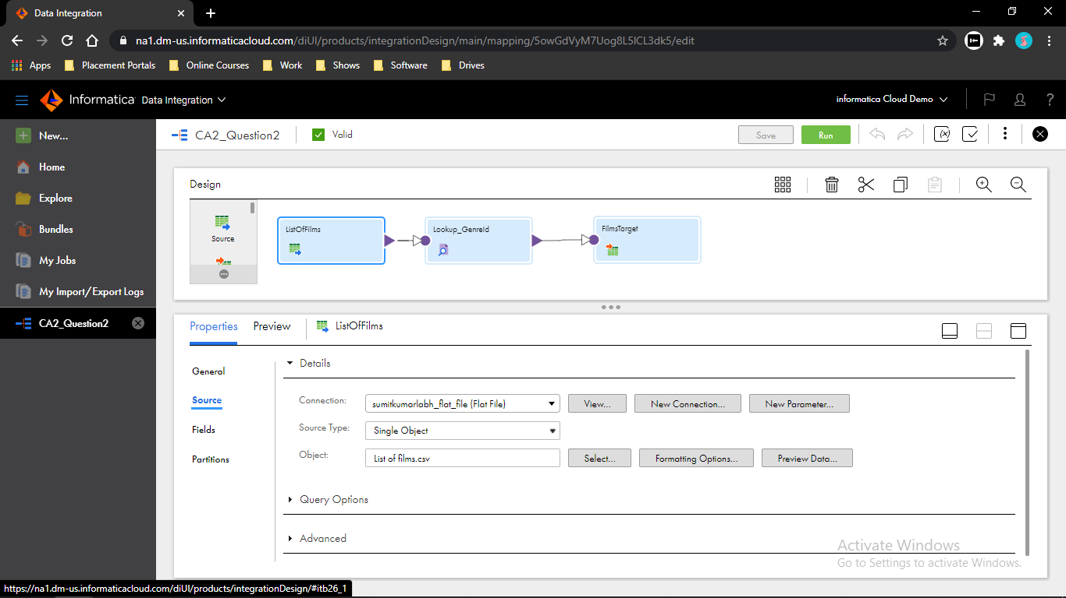

Step 2: - Insert a Lookup transformation and go to Lookup Object option then create a flat file connection and give a object to it.

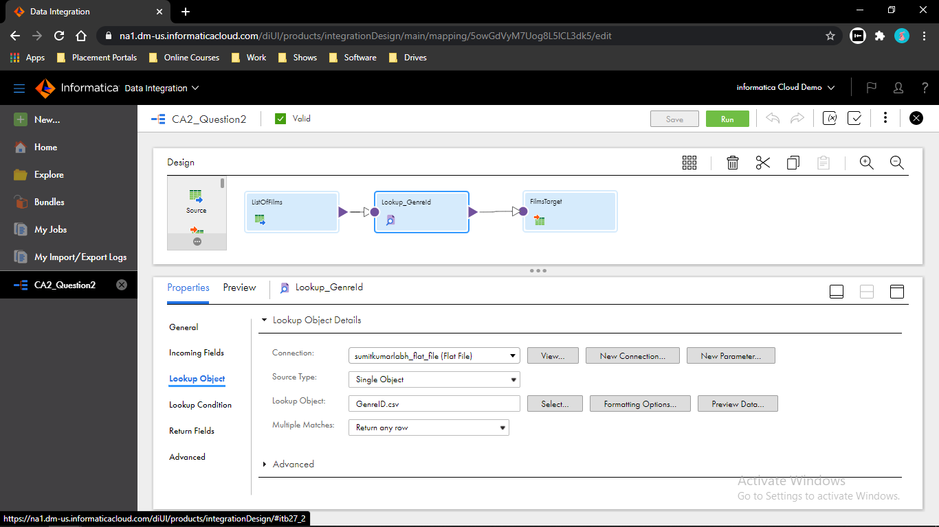

Step 3: - Go to Lookup Condition and give a condition to it. Genre = Genre_

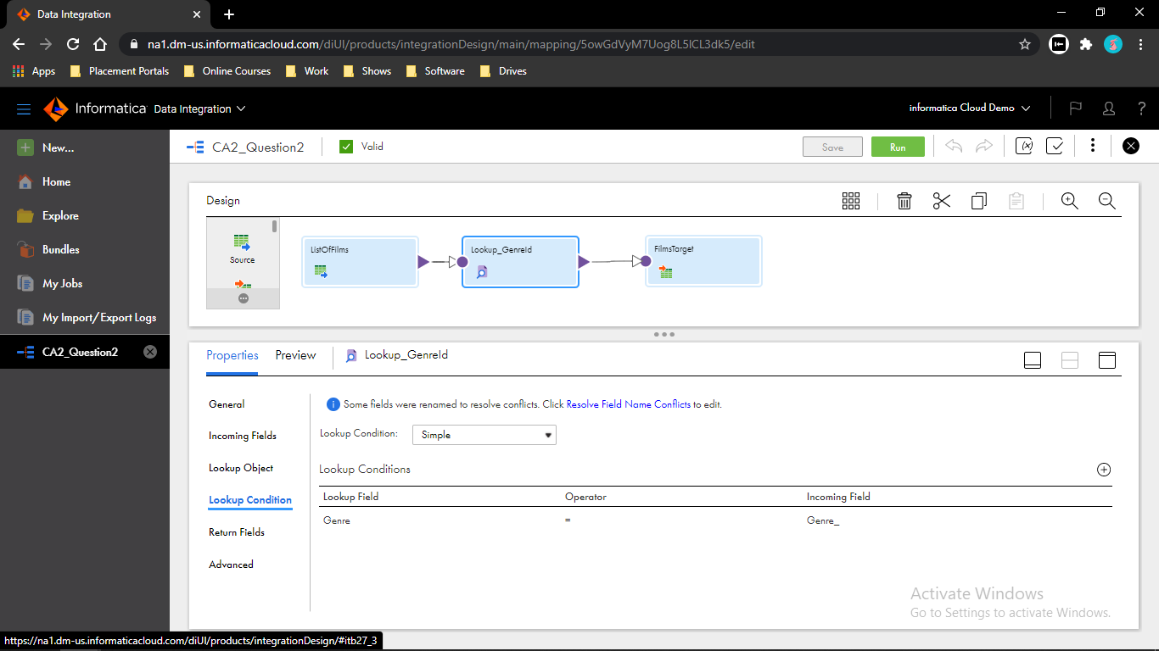

Step 4: - Go to Target and create a flat file connection and select an object for it.

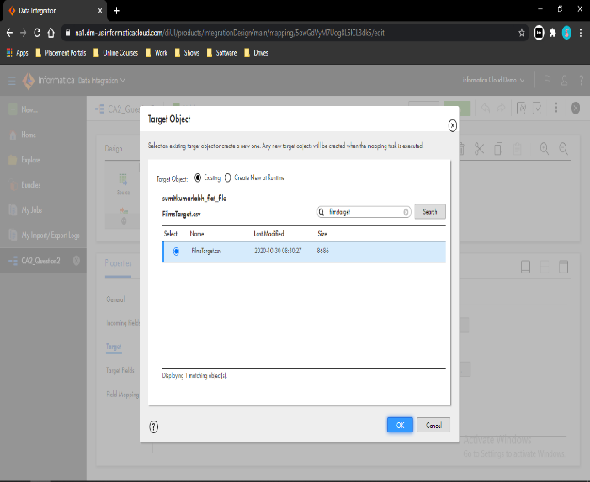 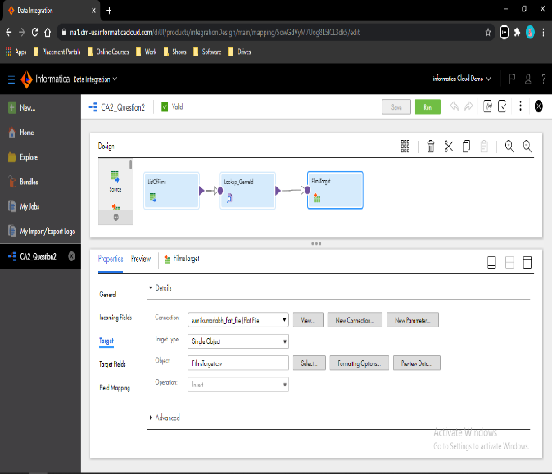

Step 5: - Go to Field Mapping and map the data then save it and run it. Go to My Jobs to see the execution.

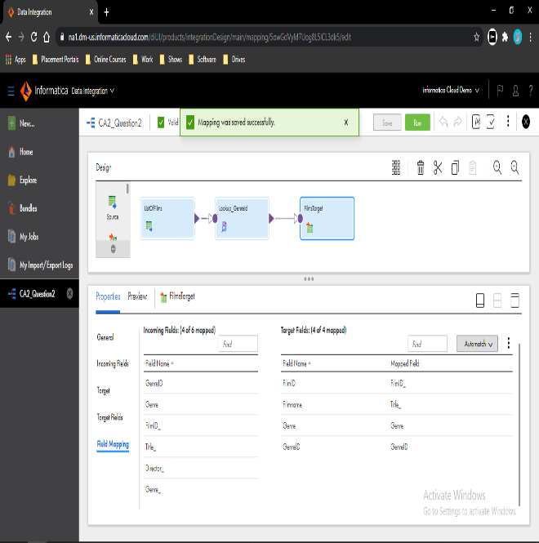 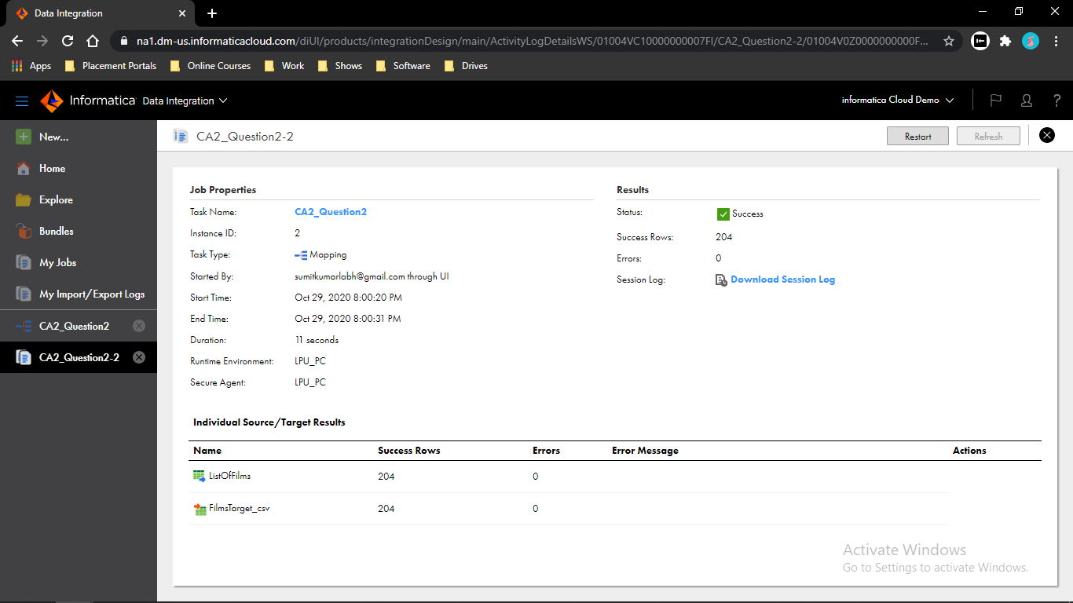

**Question 3: -** You are given a file emp_data.txt Lets suppose I am having a dataset employee containing 5 columns(id,fullname, Salary, Department,JoiningDate). How can we extract First name and Last name column values from the given column Full name in the source file? Create your own target file Complete this task using Expression Macros and implement the mapping using mapping task.

Step 1: - Select the new option from the upper left corner and go to task then select Mapping then click in create. Select Source and create a flat file connection and assign an object to it.(Employees.txt)

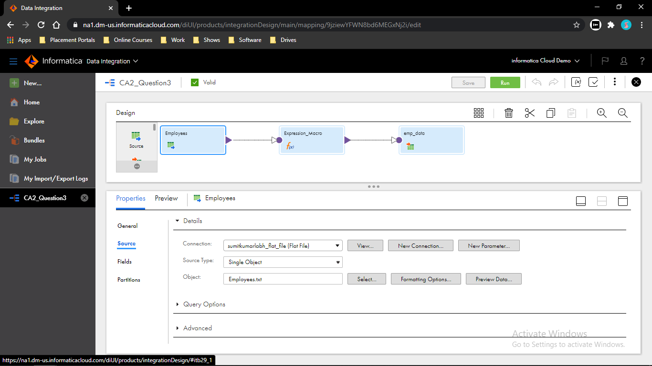

Step 2: - Insert an Expression transformation then go to expression option then create one Input Macro Field then configure it.

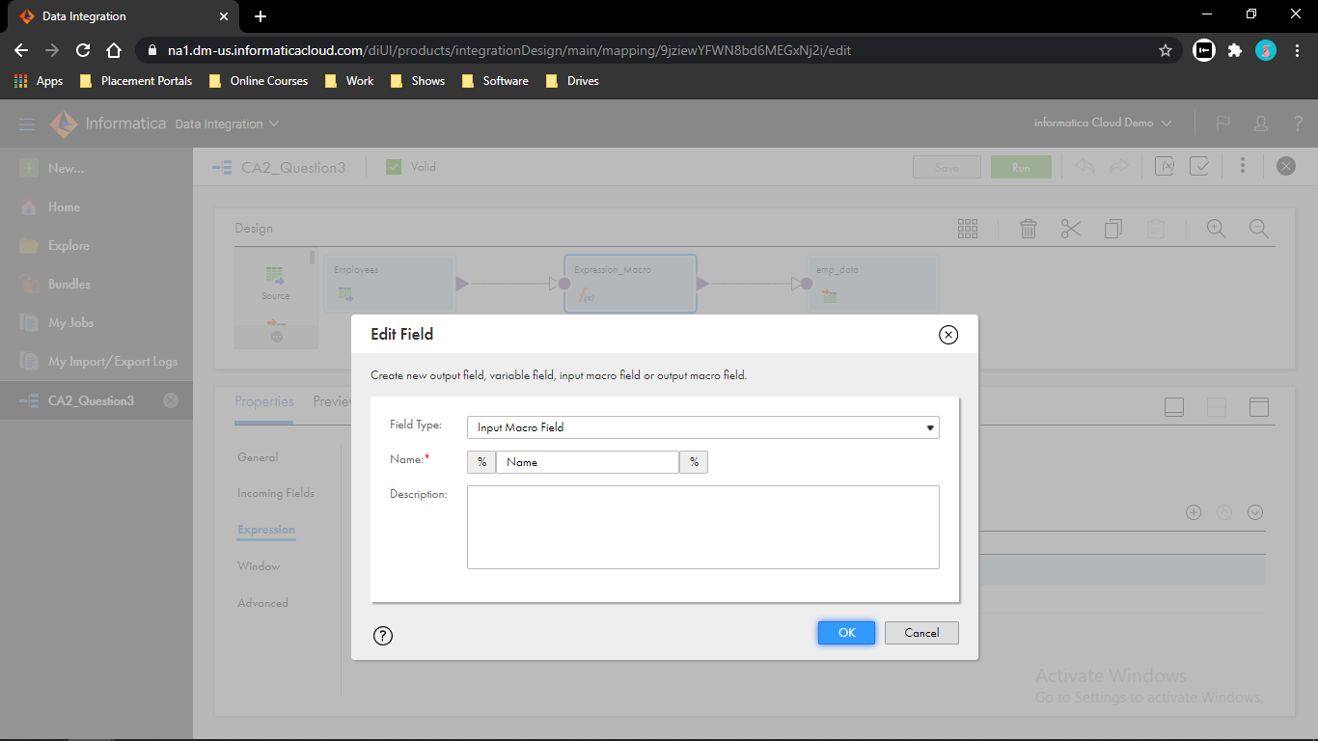

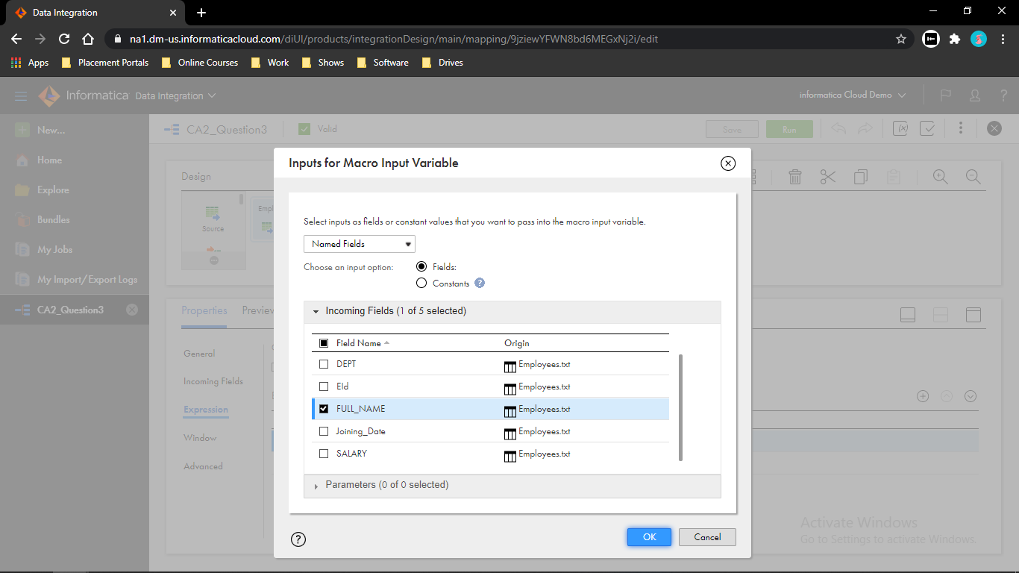

Step 3: - Go to expression option and create a Output Macro Field for First Name then configure it. SUBSTR(%Name%,1,INSTR(%Name%,’’,-1,1)-1)

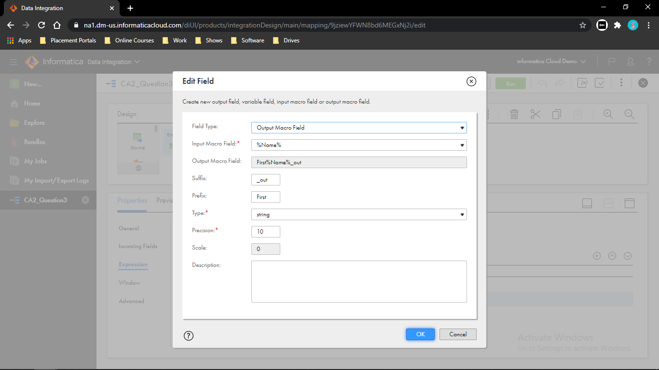

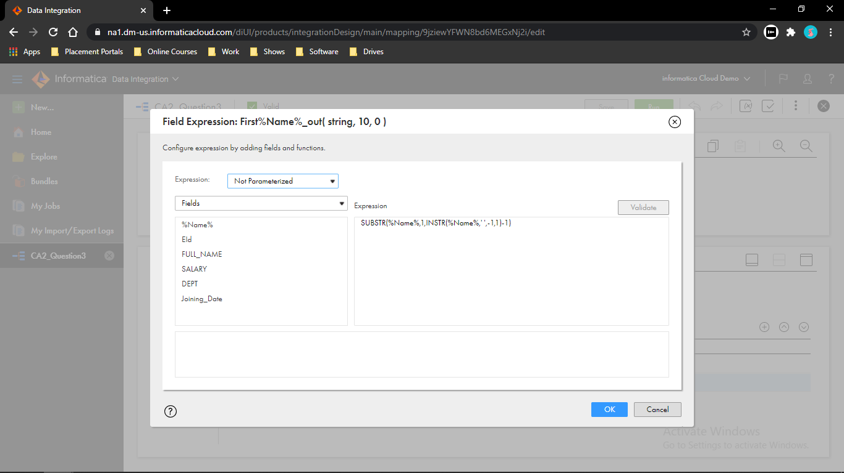

Step 4: - Go to expression option and create a Output Macro Field for Last Name then configure it. SUBSTR(%Name%,1,INSTR(%Name%,’’,-1,1)+1,LENGTH(%Name%))

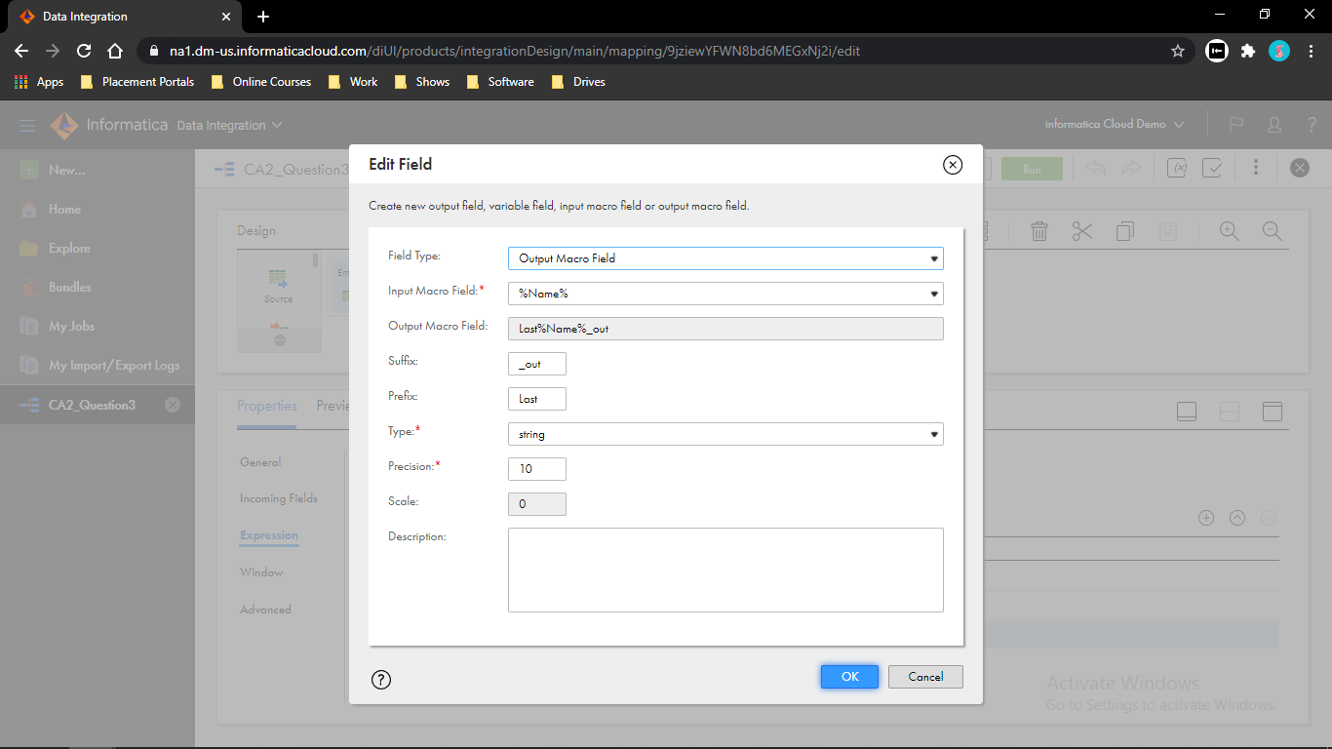

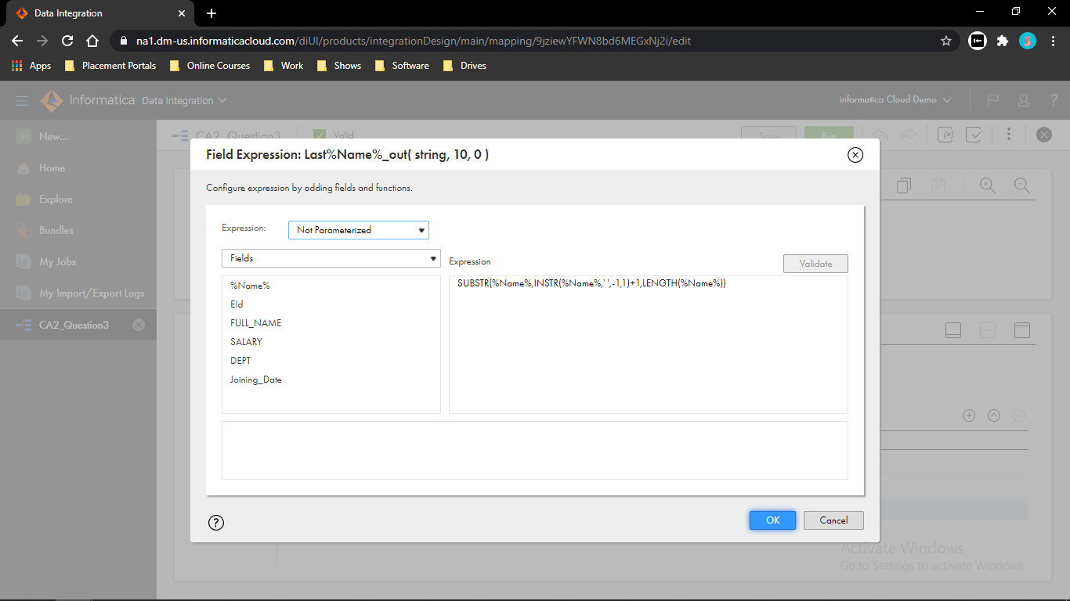

Step 5: - Go to Target and create a flat file connection and create an object for it and save the mapping.

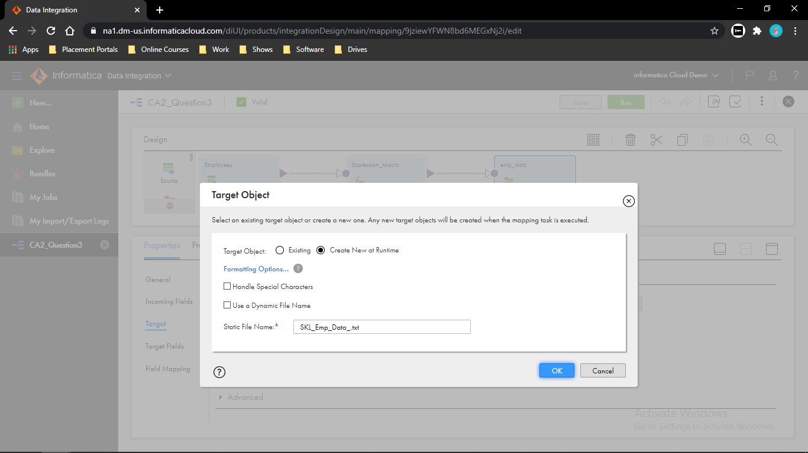

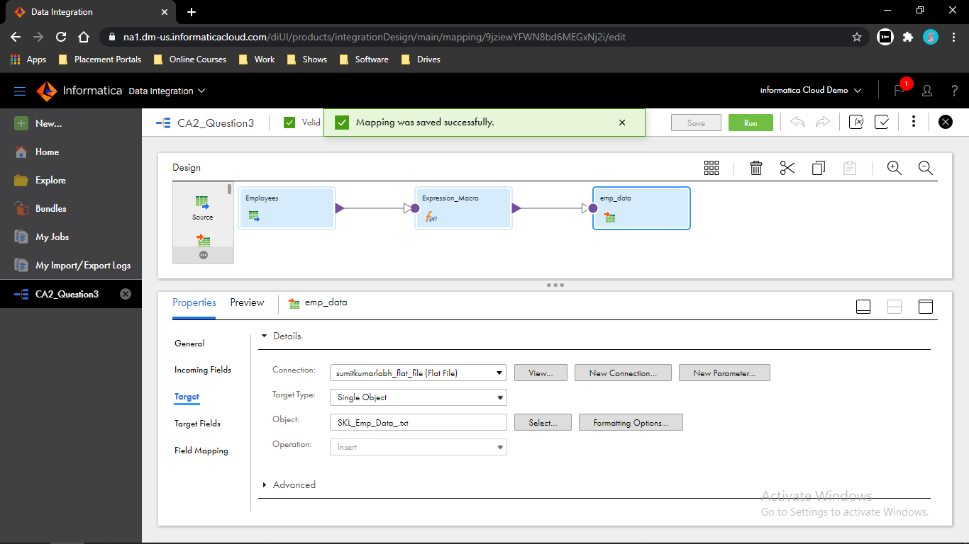

Step 6: - Run the mapping then go to My Jobs to see the execution.

